|  |  |
| --- | --- |
| No. of Pages | **4**  A |
| No. of Questions | **3** |

**Department of Computer Science and Engineering**

**MIDTERM EXAMINATION FALL 2017**

**CSE421: Computer Network**

**Total Marks: 45 Time Allowed: 50 minutes**



* Answer ALL **THREE (3)** questions
* Figure in bracket [] next to each question indicates marks for that question



**Question 1**

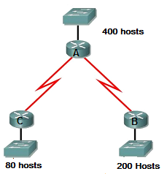

**Figure no. 1**

1. Suppose a company is given a block **220.32.192.0/22.** But you need three more sub networks for your organization and two more for the WAN Links as shown in figure no. 1. Show how you can have 5 more subnets out of the original network address as per host requirements. Do not forget to show basic calculations. [7.5 marks]

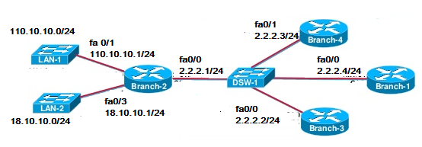

**Figure no. 2**

1. The network administrator wishes to create a static route in Branch-2 Router for the LAN-1 network 110.10.10.0/24 of Branch-1 Router as shown in figure no. 2. Which of the following command will be efficient and why? [4 marks]
   1. **ip route 110.10.10.0 255.255.255.0 fa0/0**
   2. **ip route 110.10.10.0 255.255.255.0 2.2.2.1**
2. The **show ip route** command gives the following output shown in figure no. 3. The router receives a packet destined for 192.168.4.5/24. The static route for 192.168.4.0/24 does not have the exit interface. So which of it’s interface shall the router choose to send the packet through and how will the router find that exit interface? [3.5 marks]

**C 192.168.2.0/24 is directly connected, Ethernet0/0**

**C 192.168.5.0/24 is directly connected, Serial0/0**

**C 192.168.1.0/24 is directly connected, Serial0/1**

**R 192.168.3.0/24 [120/1] via 192.168.5.1, 00:00:03, Serial0/0**

**R 192.168.6.0/24 [120/2] via 192.168.5.1, 00:00:12, Serial 0/0**

**S 192.168.4.0/24 [1/0] via 192.168.2.1**

**Figure no. 2**

**Figure no. 3**

**Question 2**

|  |  |  |  |  |
| --- | --- | --- | --- | --- |
| **Node M Table** | | |  |  |
|  | **M** | **N** | **O** | **P** |
| **M** | 0 | 12 | 5 | ∞ |

|  |  |  |  |  |
| --- | --- | --- | --- | --- |
| **Node N Table** | | |  |  |
|  | **M** | **N** | **O** | **P** |
| **N** | 12 | 0 | 4 | ∞ |

|  |  |  |  |  |
| --- | --- | --- | --- | --- |
| **Node O Table** | | |  |  |
|  | **M** | **N** | **O** | **P** |
| **O** | 5 | 4 | 0 | 3 |

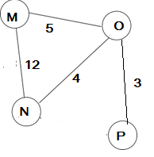

**Figure no. 4**

1. The tables represent the routing table of Router M, N and O at a single point of time. Router N receives updates from M and O routers. All routers are running Distance Vector algorithm. How will Router N calculate the best paths to all destinations after receiving the updates from M and O only? (Use Dx(y) = min{c(x,y) + Dy(y), c(x,z) + Dz(y)} for explaining your answer) [6 marks]

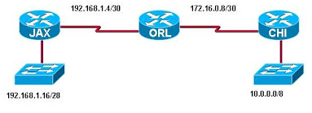

**Figure no. 5**

1. JAX, ORL and CHI routers of figure no.5 are all running RIPv2. Routing updates are being sent through all of the interfaces of all three routers. This is creating congestion in the internal networks, how can we solve this problem? [3 marks]

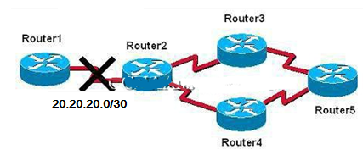

**Figure No. 6**

1. Refer to the above figure no.6, Router3 after not receiving any update from Router2 for 180 secs considers that the network 20.20.20.0/30 between Router2 and Router1 is down. So it starts its holddown timer of 180 secs for that network. Then in a few seconds it receives an update from Router5 stating that the network 20.20.20.0/30 between Router1 and Router2 is 1 hop away.
   1. Will Router3 update the route for the link to up, why or why not?
   2. If it does not receive any updates regarding the network at all, what will Router3 do? [3+3 marks]

**Question 3**

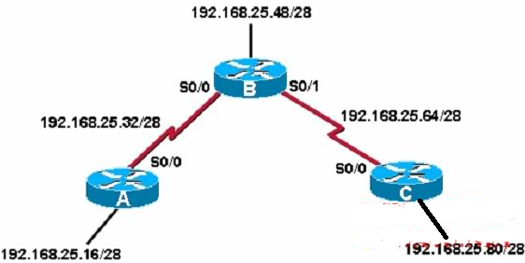

**Figure no. 7**

1. In the topology shown in the above figure no.7, all routers are running OSPF . Should we turn on “auto-summary” in routers A and B to keep our routing tables small? Why or why not? [3 marks]

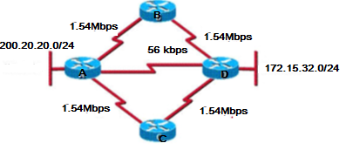

**Figure no. 8**

1. Refer to figure no.8, all routers are running OSPF routing protocol. Which path/s will Router A take to send packets to network 172.15.32.0/24. Explain your answer briefly. [4 marks]
2. What states do a router go through while exchanging hello packets? [2 marks]

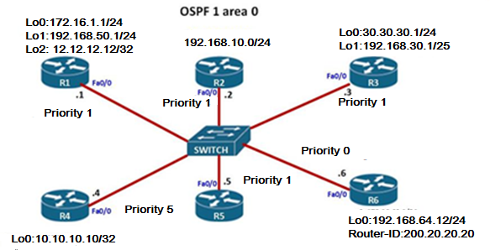

**Figure no. 9**

1. In the above figure no.9, all routers are running OSPF routing protocol. In the above scenario identify router IDs of each router and select the DR and BDR. [3+3 marks]

**THE END**